

**UNIVERSITI MALAYSIA TERENGGANU**

**CSM3023 – WEB PROGRAMMING 2**

**BACHELOR OF COMPUTER SCIENCE (MOBILE COMPUTING) WITH HONORS**

**LAB 5 – JSP: JavaBeans & Java Standard Tag Library (JSTL)**

**SEMESTER II 2023/2024**

**Prepared for:**

DR MOHAMAD NOR BIN HASSAN

**Prepared by:**

AHMAD SHAZRUL IZZUAN BIN AHMAD FITIRI @ FITRI

(S67250)

**Task 1: Using Scriplet to Access a Simple JavaBeans**

Code :

Message1.jsp

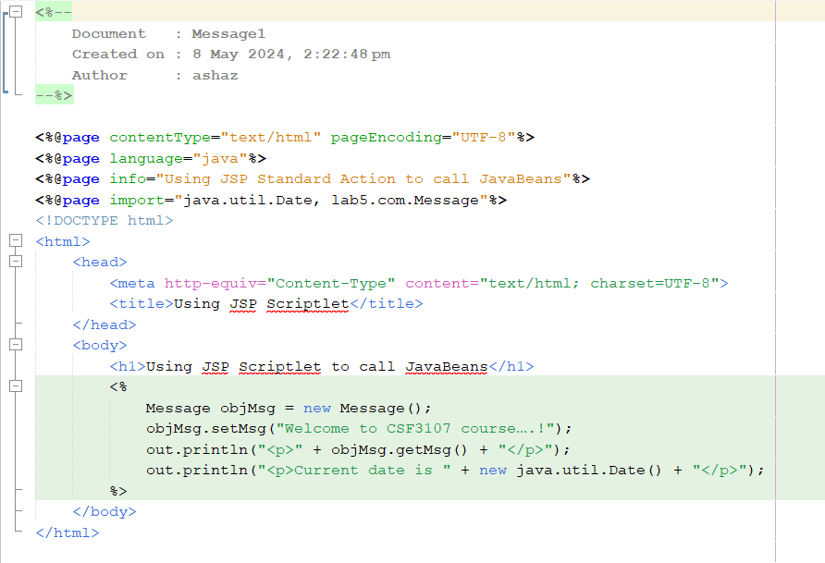

Message.java

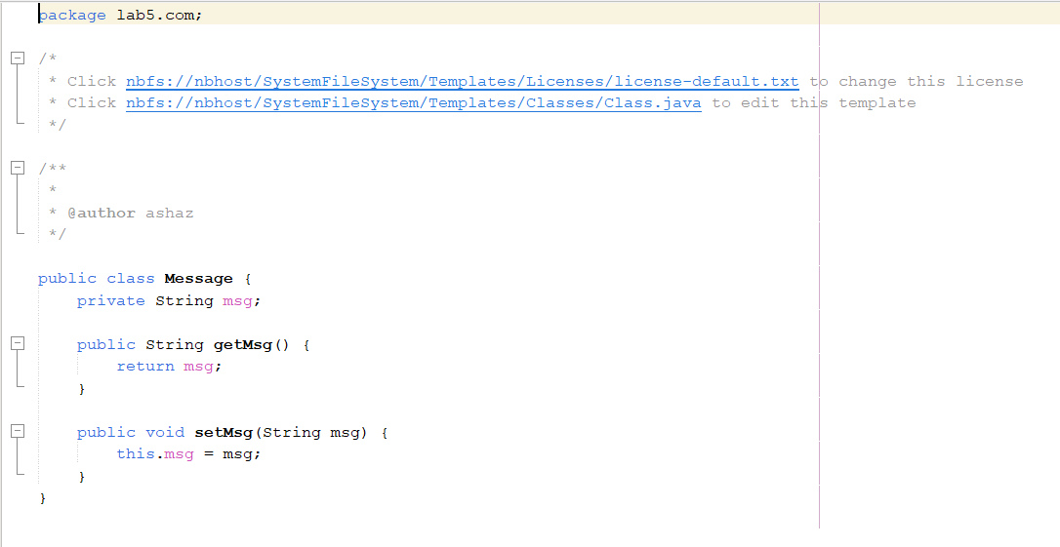

Output :

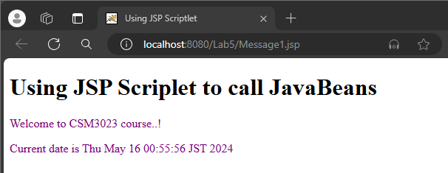

**Reflection**

1. What you have learnt from this exercise?

* How to show a message, time and date using JSP.

1. Explain the differences when calling JavaBeans using JSP Standard Action and Java Scriptlet.

* While Java Scriptlet mixes Java code directly within HTML, calling JavaBeans using JSP Standard Action uses tags to isolate business logic from display.

**Task 2: Problem Solving using JavaBeans**

Code :

registerTraining.jsp

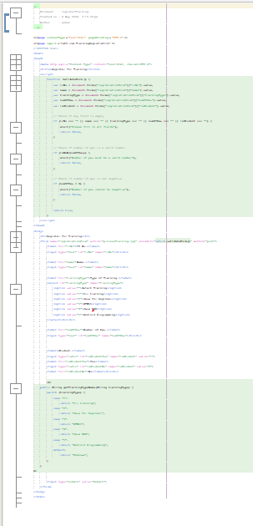

processTraining.jsp

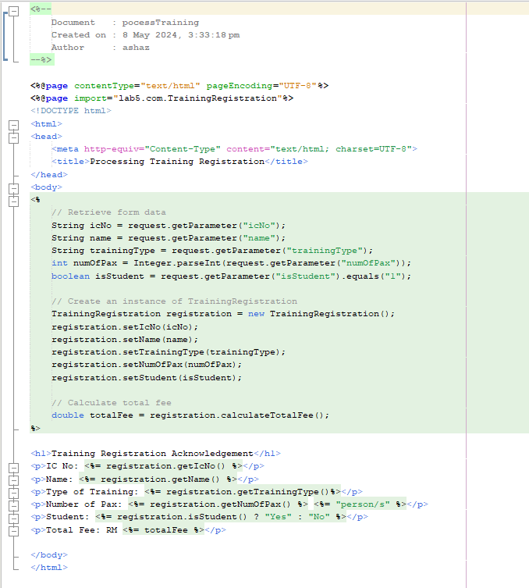

TrainingRegister.java

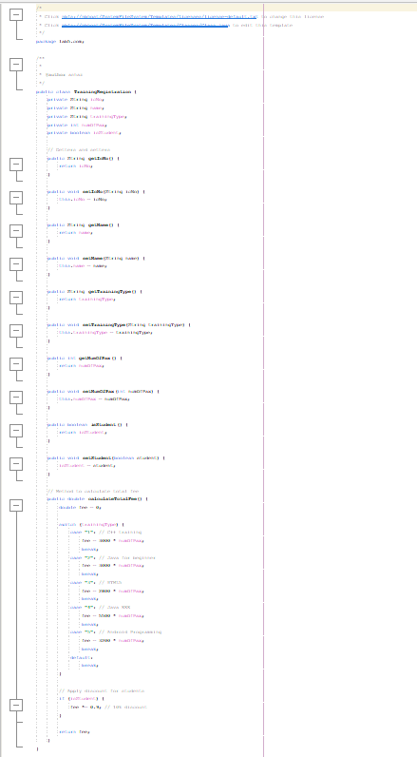

Output :

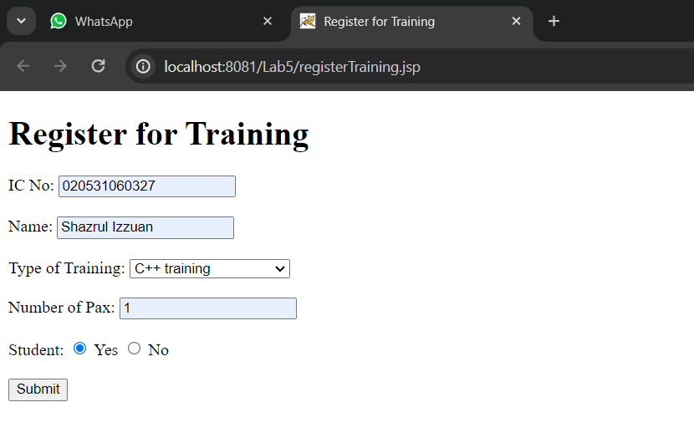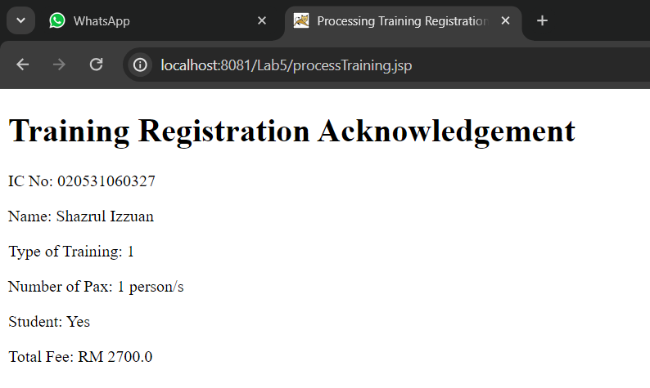

**Reflection**

1. What you have learnt from this exercise?

* How to show the registration detail.

1. Describe the steps how you construct Register JavaBeans?

* Make a Java class having private properties, public getter and setter methods for each property, and a no-argument constructor in order to build Register JavaBeans.

**Task 4: Using Java Standard Tag Library (JSTL)**

* **Task 1 Assign value “ W elcome to CS F3107–Web Programming courses” and display the value inside JSP page**

Code :

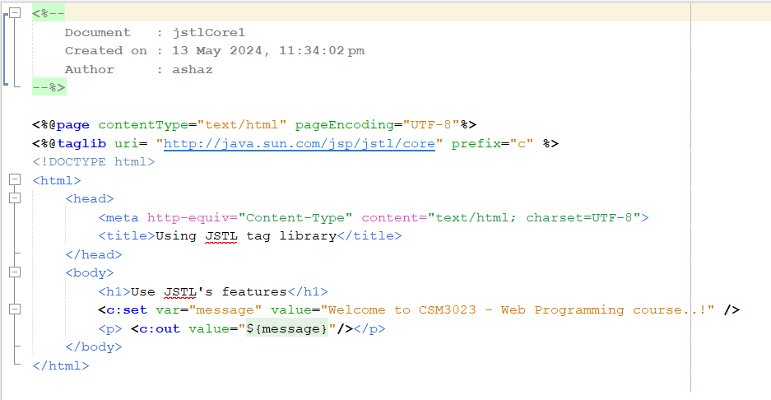

Output :

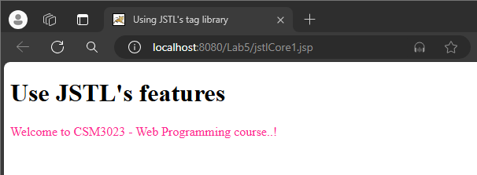

* **Task 2-Using JSTL’s core to request information from one page and display the information**

Code :

userRegistration.html

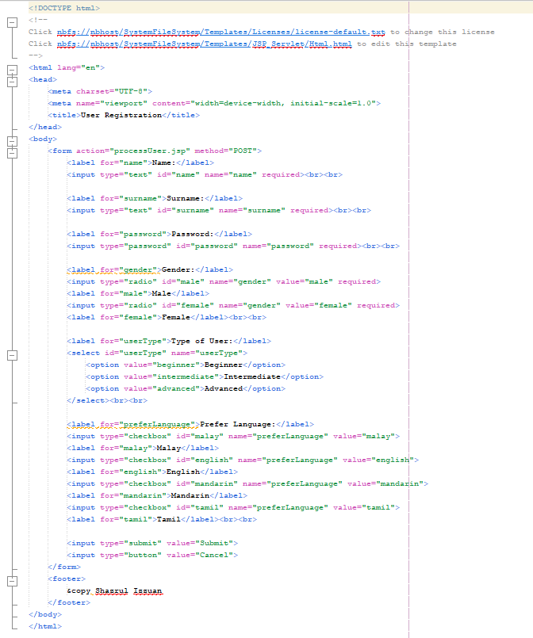

processUser.jsp

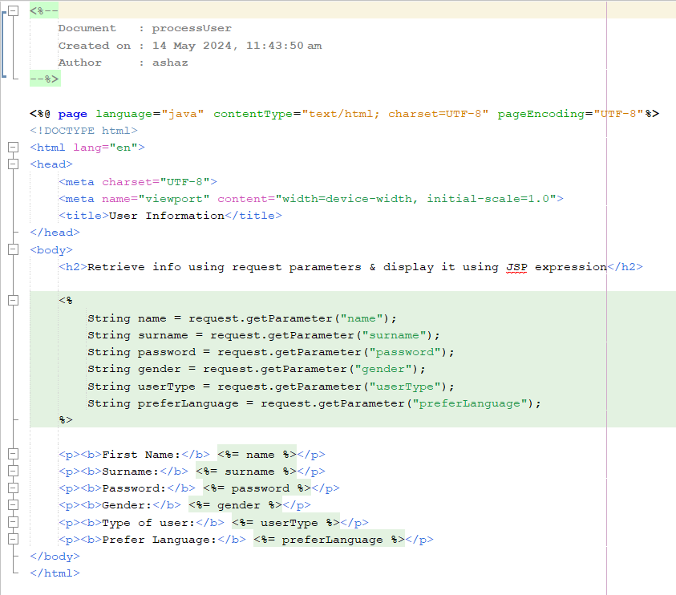

Output :

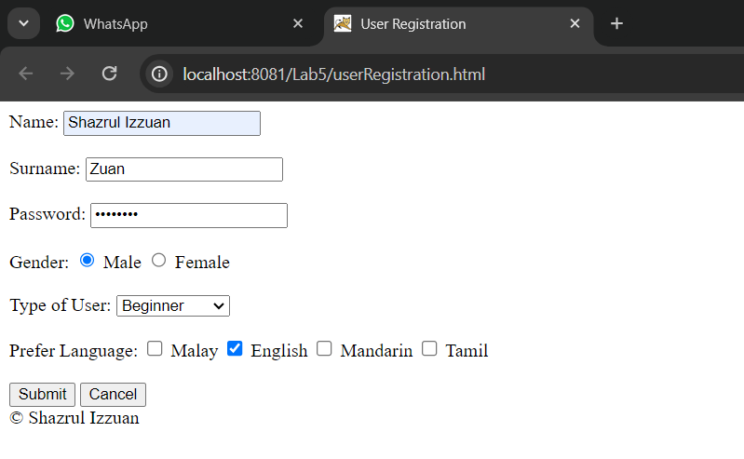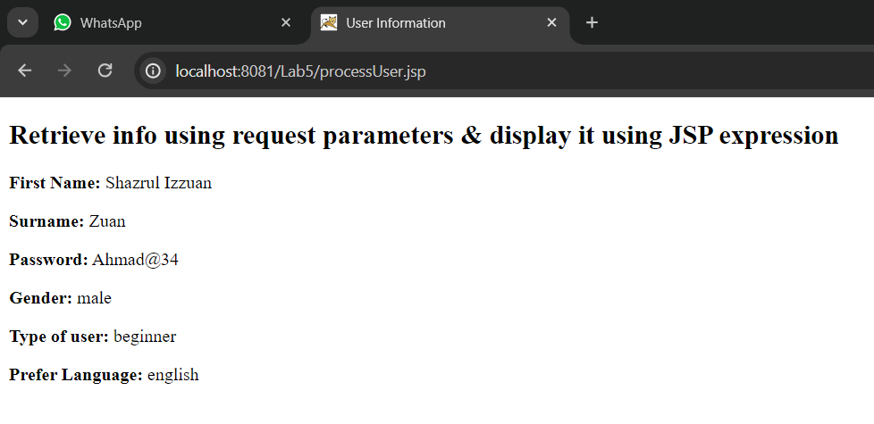

* **Task 3 - Using JSTL’s fmt to format number and currency**

Code :

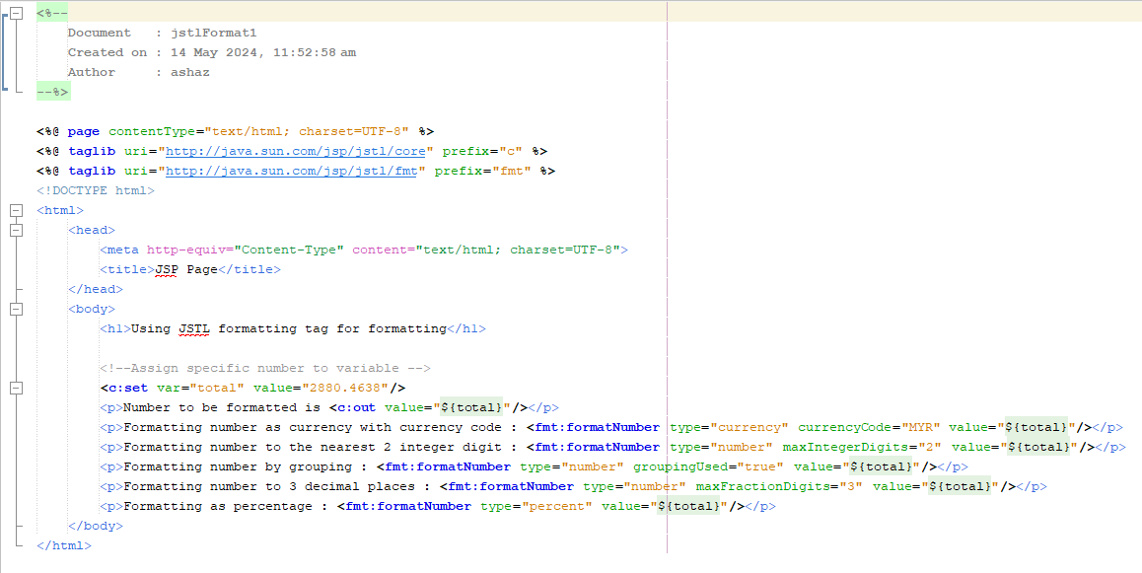

Output :

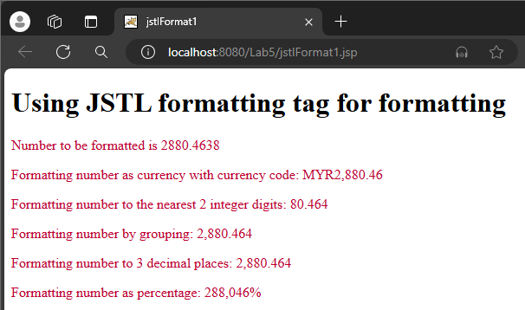

**Reflection**

1. What the purpose of using JSTL’s tag library?

* JSTL's tag library is meant to make the process of creating dynamic web pages easier by offering reusable, standard tags for common tasks like data formatting, conditionals, and iteration.

1. List FIVE(5) categories of JSTL library.

* Core
* Formatting
* SQL
* XML
* Functions

**Task 5: Using JSP Standard Tag Library**

* **Task 1 Using JSTL’s fmt to format Date**

Code :

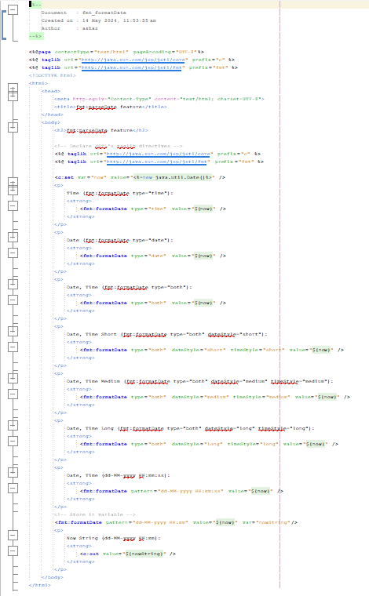

Output :

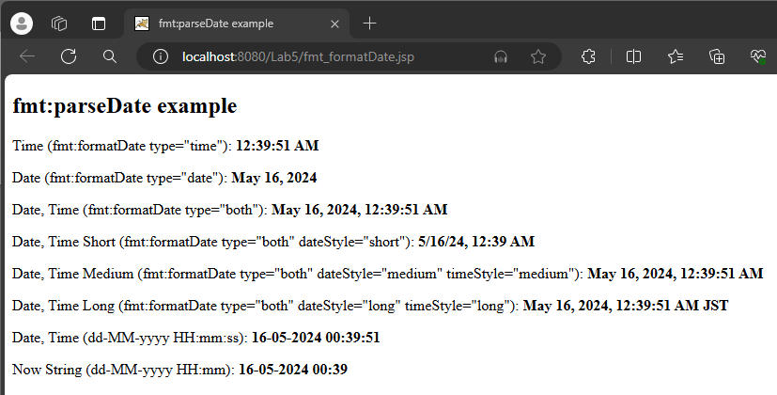

* **Task 2 - Using JSTL’s fmt to Parse Date**

Code :

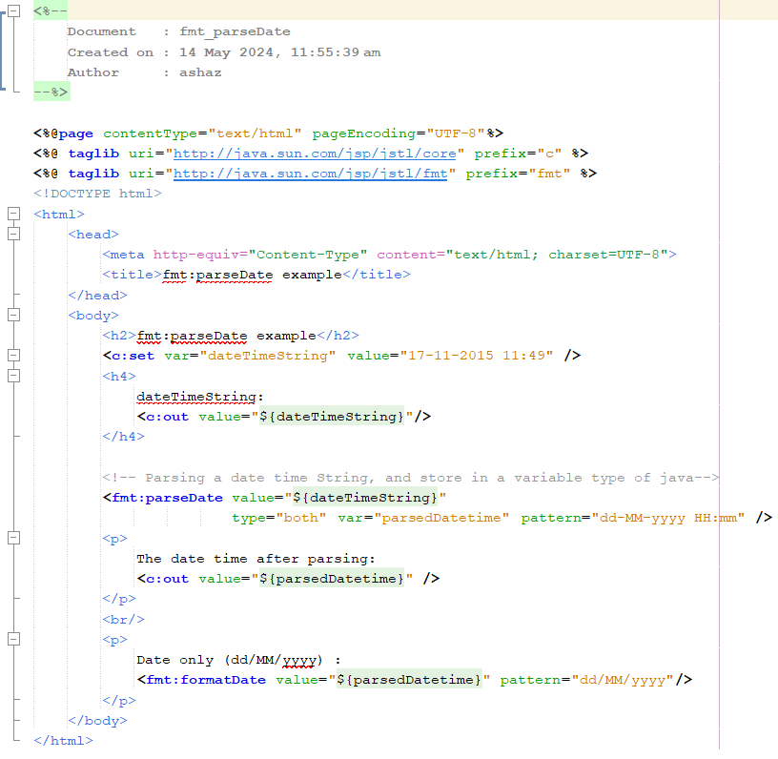

Output :

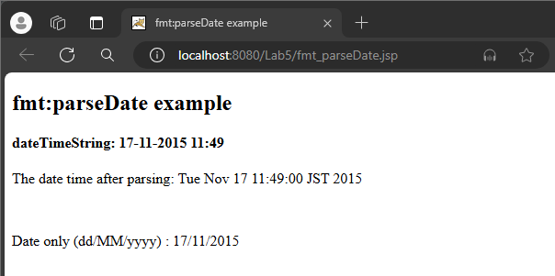

**Reflection**

1. What you have learnt from this exercise?

* To get the details time and date using JSP.

**Exercise**

* **Number 1**

Code:

circle.jsp

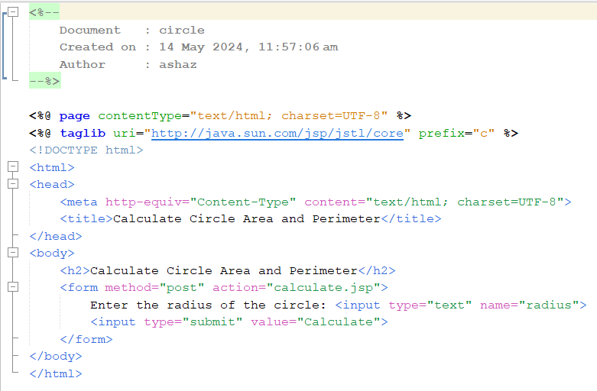

calculate.jsp

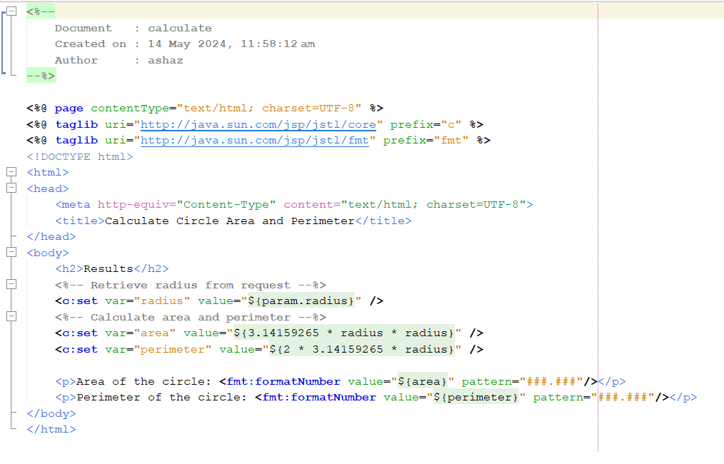

Output:

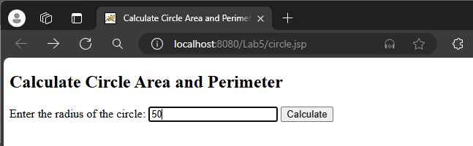

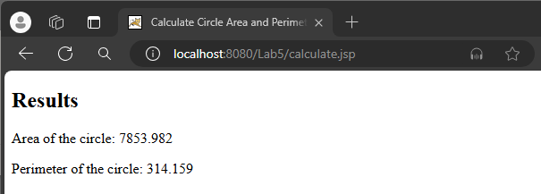

* **Number 2**

Code:

brokerage.jsp

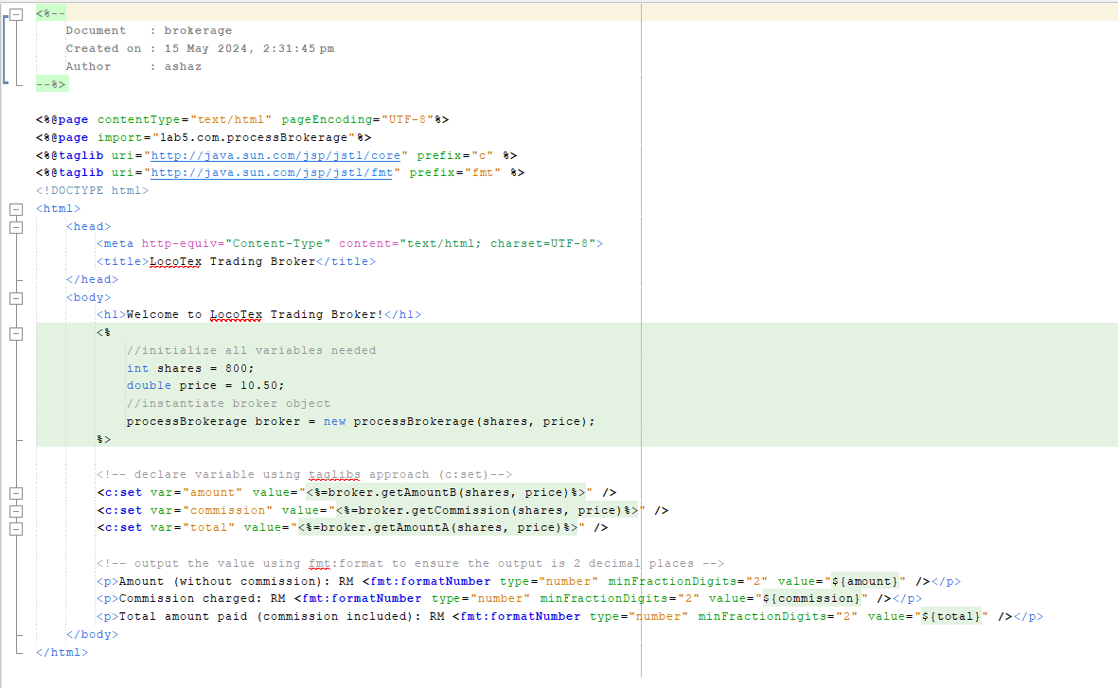

processBrokerage.java

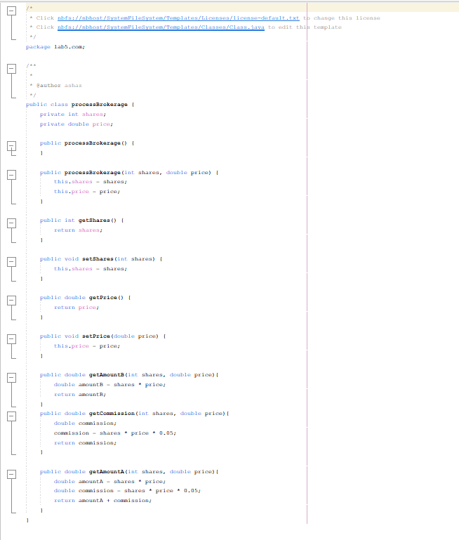

Output:

